MACH4METAL

metalworking machinery
Transito 21,
6909 DA BABBERICH, Netherlands
Tel. + 31 (0)316 – 247123
Fax. + 31 (0)316 - 247956
info@mach4metal.com
www.mach4metal.com

Bank No : 66.52.13.883
IBAN : NL33 INGB 0665 2138 83
BIC : INGBNL2A

AMADA HA 400 band saw automat
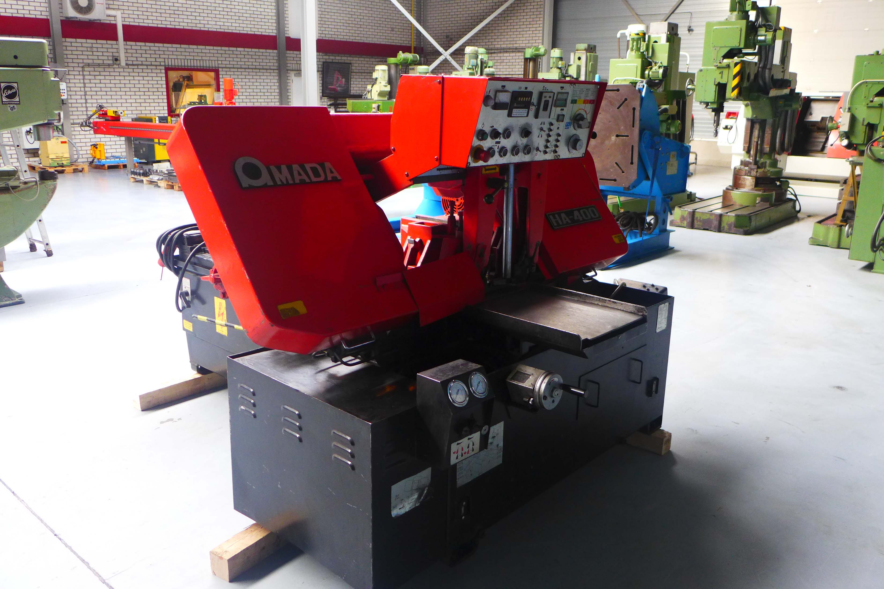
- Make : AMADA Japan
- Type : HA 400
- Age : 1982
- Mach.No. : 40600356

Sawing Capacity
- Ø : 400 mm
- Square : 400 x 400 mm
- Flat : 400 x 400 mm
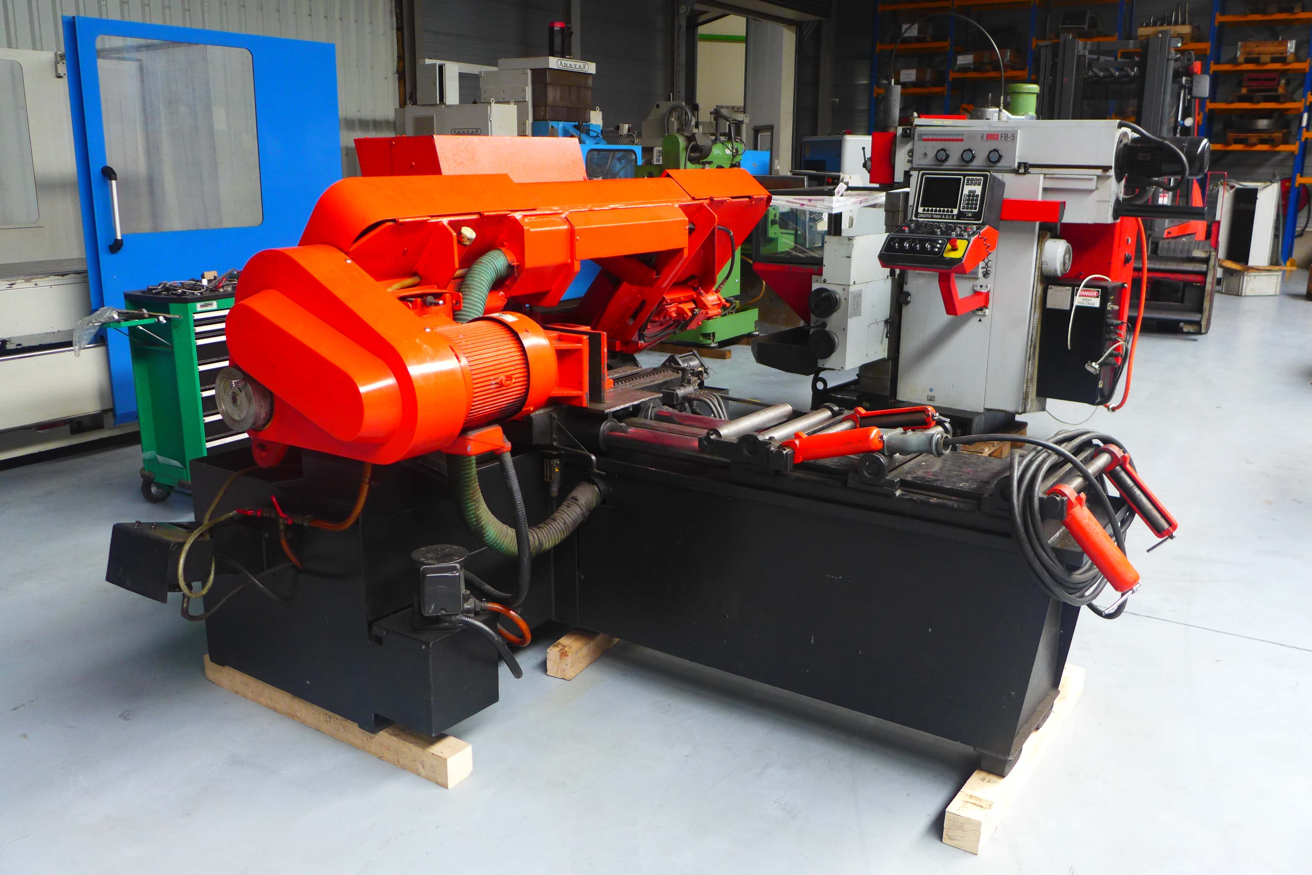
- Blade size : 4.570 x 38 x 1.06
- Load capacity : 2.500 Kg
- Sawing speed : 15 – 90 m/min
- Power blade : 5.5 kW

Auto System
* Managing the cycle of automatic
travel included various lengths in the
same quantity cycle
* Control of pressure and cutting speed
* Pressure regulation of vice clamping
* Screw chip conveyor
* Coolant system
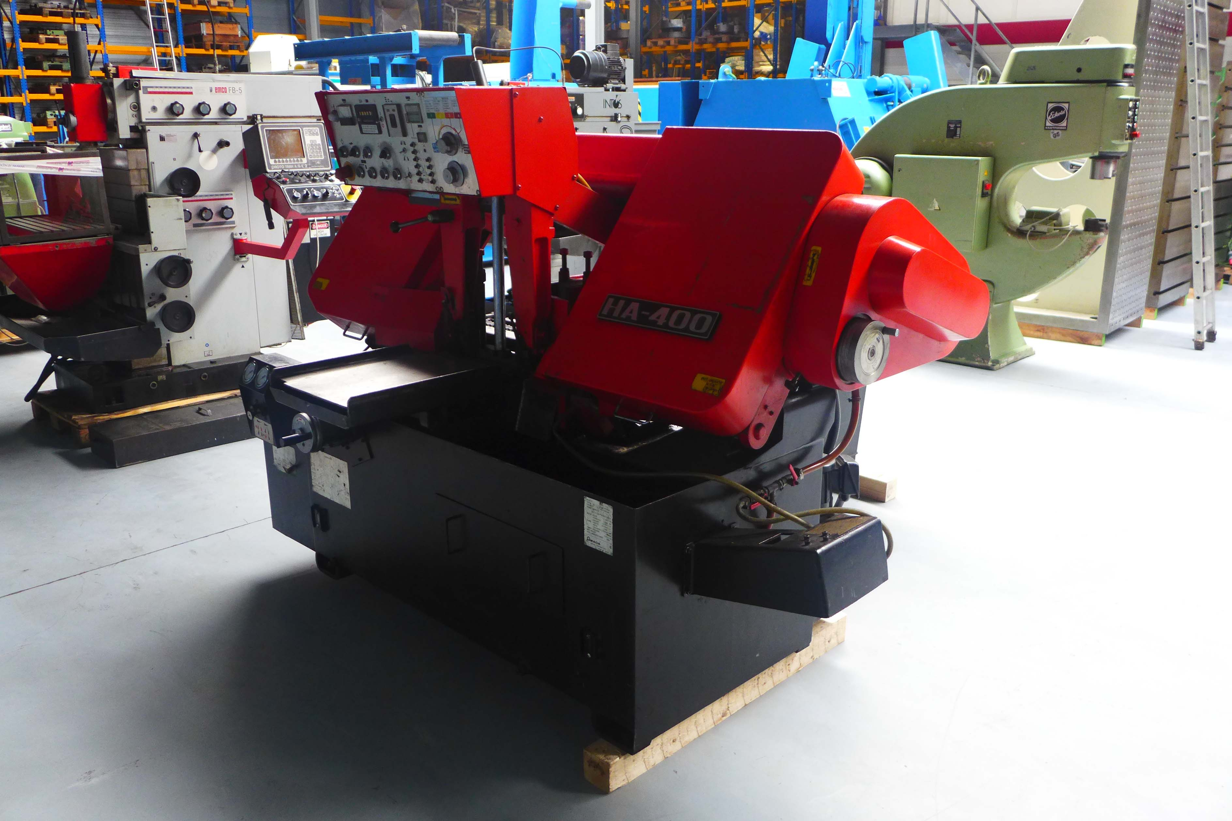

Dimensions
- Length : 2.241
- Depth : 2.639
- Height : 2.340
- Weight : 2.600

Please Note: The above information has been obtained to the best of our ability and belief from, and from the manufacturers where possible. It is given in good faith, but its accuracy can not be guaranteed. Accordingly, it will not form a representation or constitute contractual terms. We advise you to check any vital details!

